Ideas and draft

**Critical Review: Preliminary indicators of mortality in subjects infected with COVID-19 based on data from China and South Korea**

<https://www.mdcalc.com/covid-19/indicators-mortality-data-china-south-korea>

­An odds ratio (OR) is a comparison of the odds of an event or outcome in those with a particular risk factor, versus the odds of that outcome or event in those without that particular risk factor.

OR is a useful way to estimate how the presence of a risk factor increases the likelihood of an event. For example, age ≥60 years can significantly increase the risk of mortality in patients with community-acquired pneumonia (CAP).1

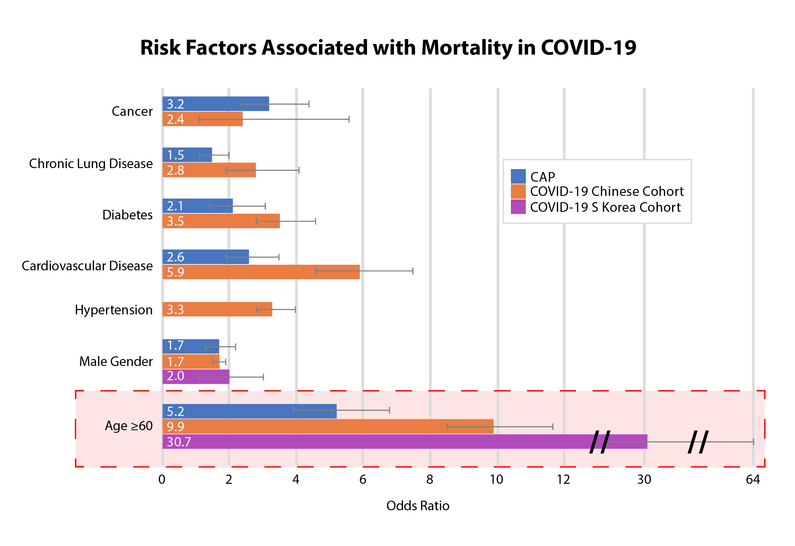

Many practicing clinicians have developed a gestalt of prognostic indicators based on experience or are familiar with scores to help prognosticate outcomes for patients with CAP. As a point of reference the ORs for CAP and COVID-19 (Table 1) are shown together in order to help clinicians put into context different risk factors with magnitudes higher ORs and similar ORs when making clinical decisions for patients with the novel coronavirus.

**Table 1: Risk factors associated with mortality in subjects infected with CAP and COVID-19**

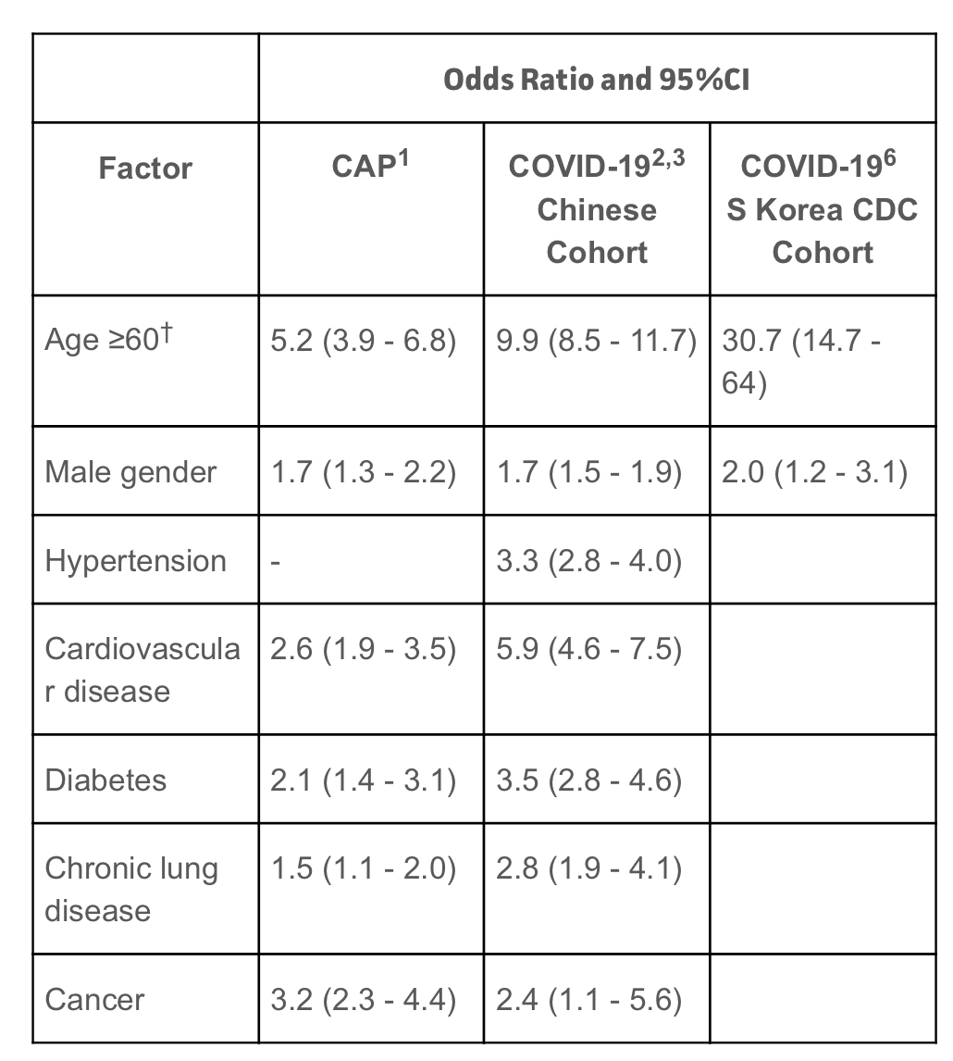

Relative risk

Male

Female

Predict death

Gender

Age

Boro

Hosp

Trend of odds ratio

new york timeline covid 19

|  |  |  |  |
| --- | --- | --- | --- |
| New York | March 22, 2020 | * May 28, 2020, for regions that have not started to reopen * Phased opening as of May 15; on a regional basis | * [Press Release](https://www.governor.ny.gov/news/governor-cuomo-signs-new-york-state-pause-executive-order) * [Press Release](https://www.governor.ny.gov/news/amid-ongoing-covid-19-pandemic-governor-cuomo-announces-nys-pause-functions-extended-additional)(extension) * [Press Release](https://www.governor.ny.gov/news/amid-ongoing-covid-19-pandemic-governor-cuomo-announces-nys-pause-extended-until-may-15) (further extension) * [Executive Order 202.8](https://www.governor.ny.gov/news/no-2028-continuing-temporary-suspension-and-modification-laws-relating-disaster-emergency) * [Executive Order 202.18](https://www.governor.ny.gov/news/no-20218-continuing-temporary-suspension-and-modification-laws-relating-disaster-emergency) * [All Executive Orders](https://www.governor.ny.gov/executiveorders) * [Littler Article](https://www.littler.com/publication-press/publication/new-york-new-jersey-and-connecticut-issue-restrictions-workplace) * [Littler Article](https://www.littler.com/publication-press/publication/covid-19-roadmap-new-york-employers) - NY Roadmap * [Executive Order 202.31](https://www.governor.ny.gov/news/no-20231-continuing-temporary-suspension-and-modification-laws-relating-disaster-emergency)(extension/regional reopening) * [Press Release](https://www.governor.ny.gov/news/amid-ongoing-covid-19-pandemic-governor-cuomo-announces-five-regions-will-begin-reopening-today)(extension to May 28) |

# New York To Expand Testing Criteria For Coronavirus, Increase Antibody

April 25, 20202:59 PM ET

# <https://www.nytimes.com/2020/04/25/nyregion/coronavirus-new-york-update.html>

# NYC broadens guidelines for who should be tested for virus

May 14, 2020

# <https://abcnews.go.com/US/wireStory/mayor-3t-house-virus-bill-nyc-cities-70677929>

# <https://www.state.gov/wp-content/uploads/2020/03/2020-03-20-Notice-New-York-on-Pause-Order.pdf>

# <https://www.governor.ny.gov/sites/governor.ny.gov/files/atoms/files/EO202.6.pdf>

1. Effective at 8PM on Sunday, March 22, all non-essential businesses statewide will be closed;

## NEW YORK

**March 22, 2020:**

Beginning at 8:00 pm on March 22nd, the [New York State on PAUSE Executive Order](https://www.governor.ny.gov/news/governor-cuomo-issues-guidance-essential-services-under-new-york-state-pause-executive-order) requires that all non-essential businesses must close in-office personnel functions statewide. Essential businesses include twelve categories as detailed in [Executive Order 202.6](https://www.governor.ny.gov/sites/governor.ny.gov/files/atoms/files/EO202.6.pdf): (1) Essential Health Care Operations; (2) Essential Infrastructure; (3) Essential Manufacturing; (4) Essential Retail; (5) Essential Services; (6) News Media; (7) Financial Institutions; (8) Providers of Basic Necessities to Economically Disadvantaged Populations; (9) Construction; (10) Defense; (11) Essential Services Necessary to Maintain the Safety, Sanitation and Essential Operations of Residences or Other Essential Businesses; and (12) Vendors that Provide Essential Services or Products, Including Logistics and Technology Support, Child Care and Services.

A business that believes it is essential but that does not fall within one of the twelve categories may request designation as an essential business by completing [this form](https://esd.ny.gov/sites/default/files/Request%20for%20Designation%20Form_0.pdf). Businesses and entities that provide other essential services must implement rules that help facilitate social distancing of at least six feet.

<https://www.huschblackwell.com/new-york-state-by-state-covid-19-guidance>

consider incubation period

<https://europepmc.org/article/pmc/pmc4889459>

time series analysis